**OPERATING SYSTEM LAB 2**

**S ABHISHEK**

**AM.EN.U4CSE19147**

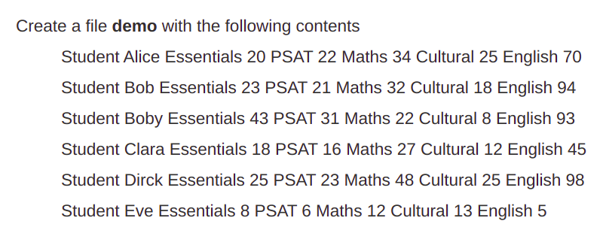

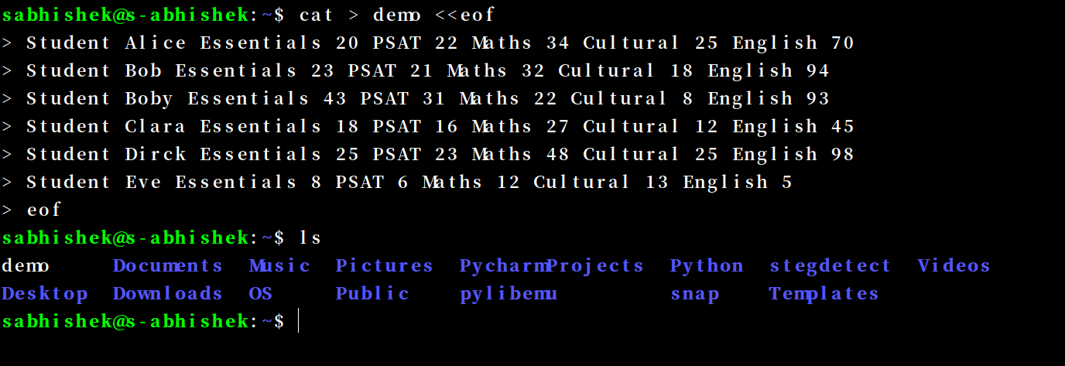







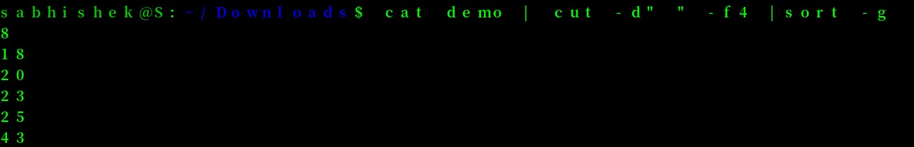











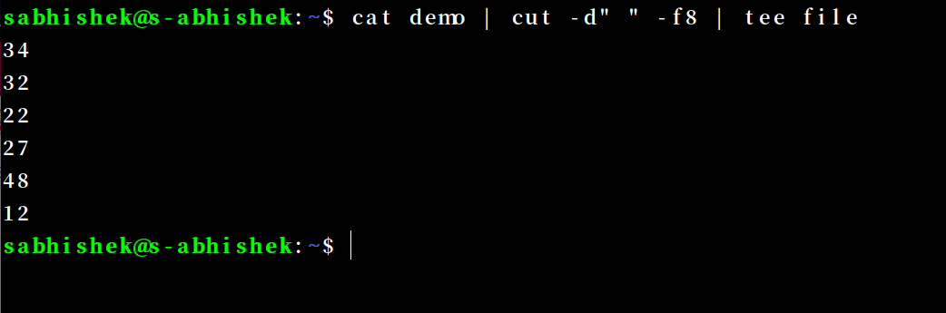



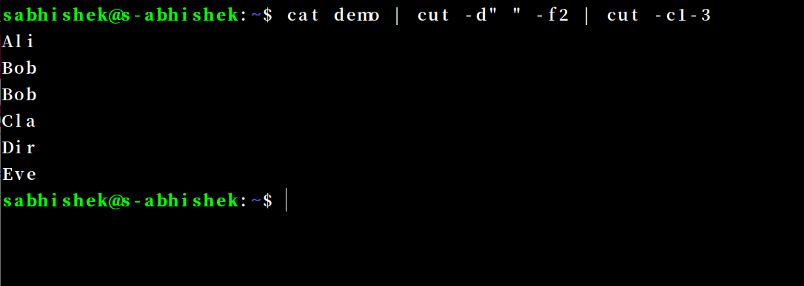



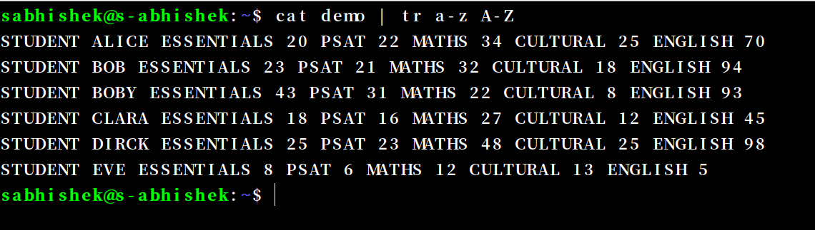



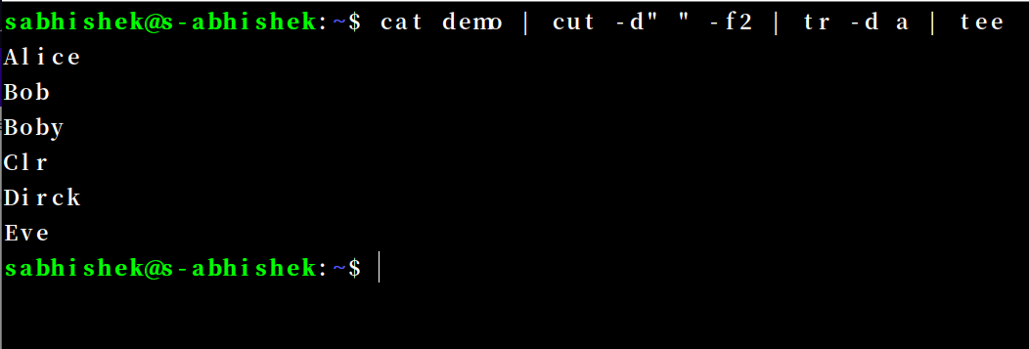



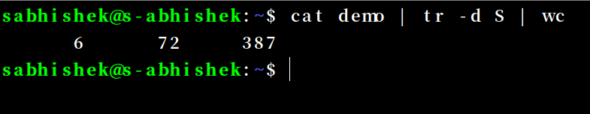



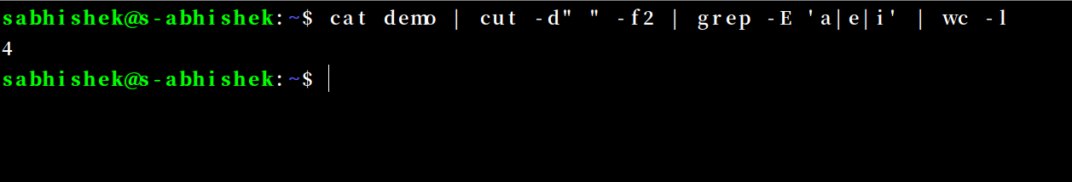



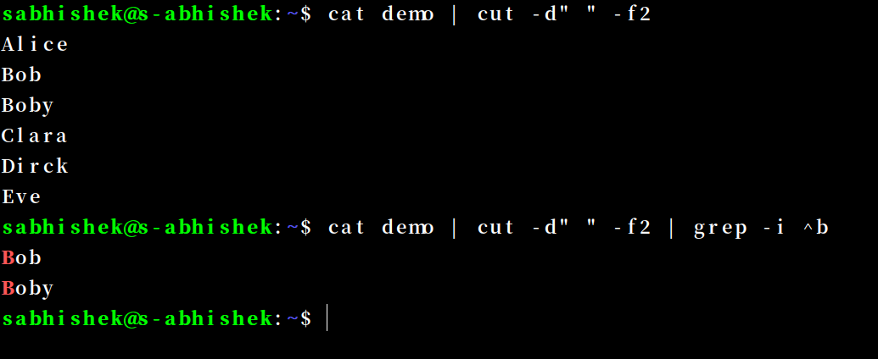



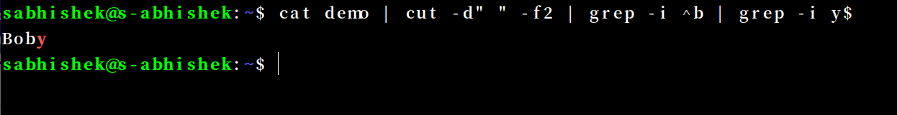

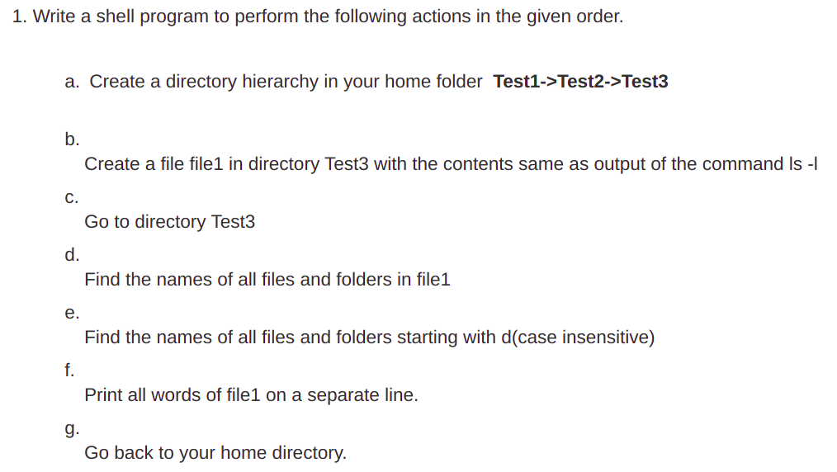

**#!/bin/bash**

**mkdir -p Test1/Test2/Test3**

**ls -l | cat > Test1/Test2/Test3/file1**

**cd Test1/Test2/Test3**

**cat file1 | tr -s " " | cut -d" " -f9**

**cat file1 | tr -s " " | cut -d" " -f9 | grep -i ^d**

**cat file1 | tr -s " " | tr ' ' '\n'**

**cd ~**

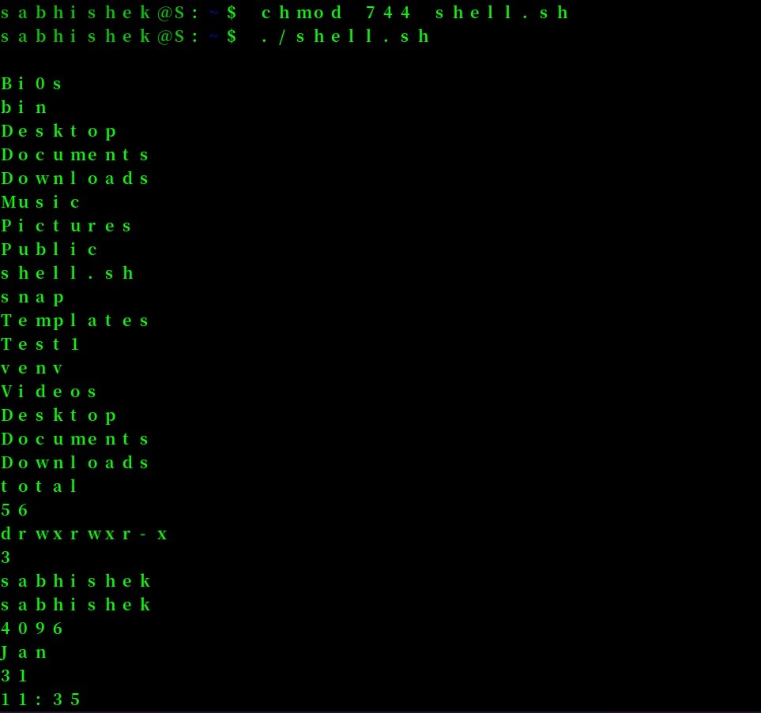 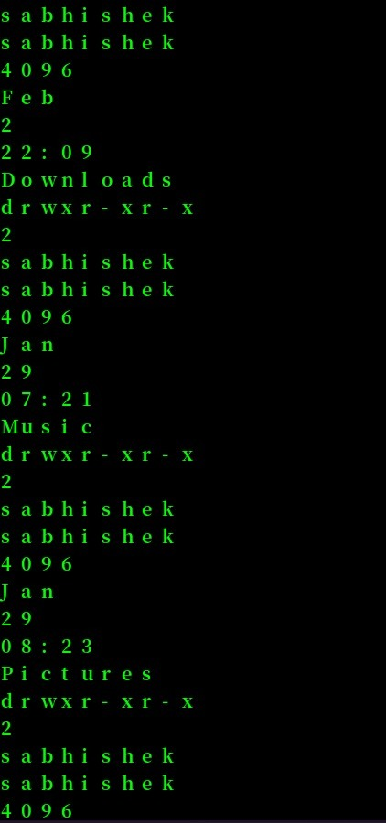

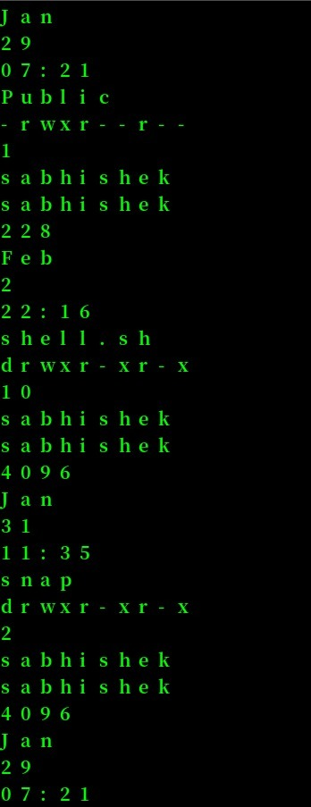

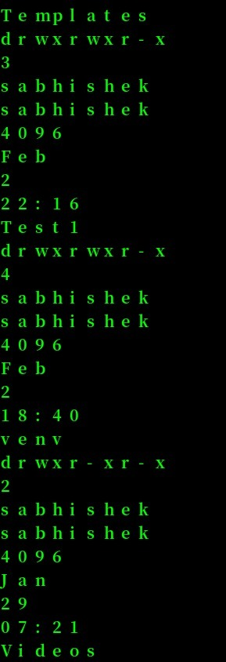

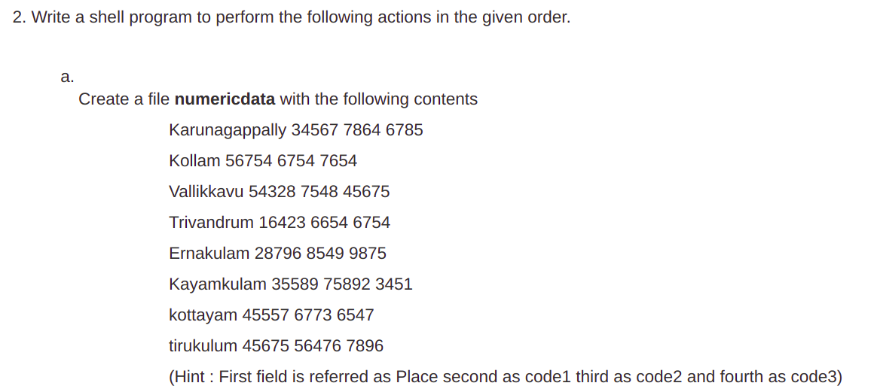

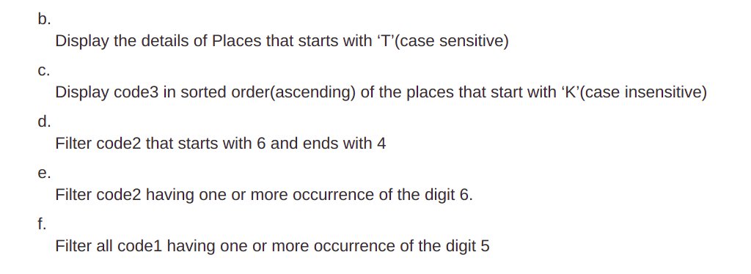

**#!/bin/bash**

**cat > numericdata << eof**

**Karunagappally 34567 7864 6785**

**Kollam 56754 6754 7654**

**Vallikkavu 54328 7548 45675**

**Trivandrum 16423 6654 6754**

**Ernakulam 28796 8549 9875**

**Kayamkulam 35589 75892 3451**

**kottayam 45557 6773 6547**

**tirukulum 45675 56476 7896**

**eof**

**cat numericdata | grep ^T**

**cat numericdata | grep -i ^k | cut -d" " -f4 | sort**

**cat numericdata | cut -d" " -f3 | grep ^6 | grep 4$**

**cat numericdata | cut -d" " -f3 | grep -E '6+'**

**cat numericdata | cut -d" " -f2 | grep -E '5+'**

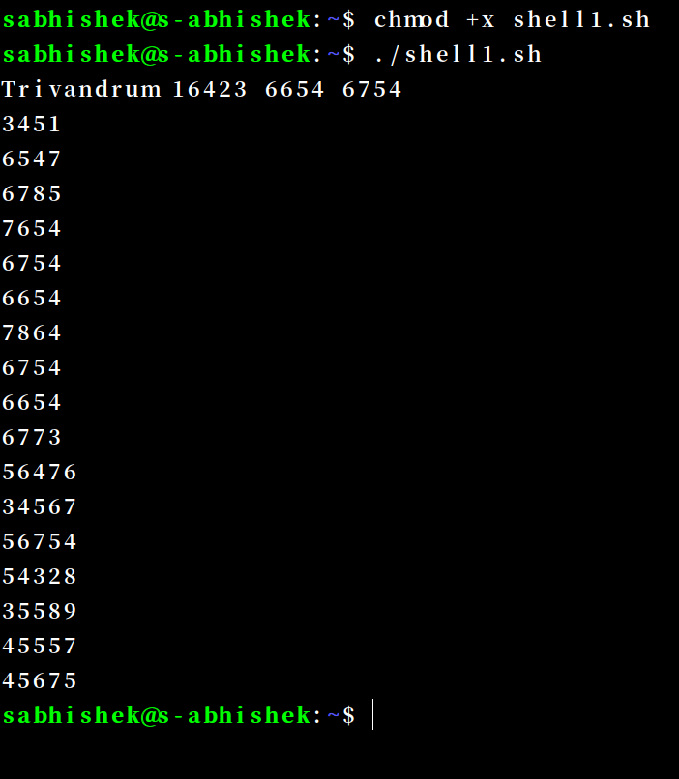

**THANKYOU!!**